Installation & Servicing Instructions
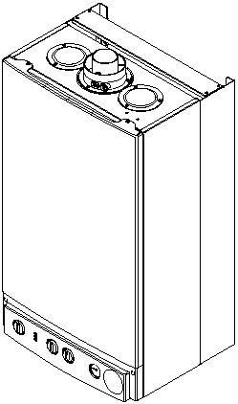
Baxi Combi 80Eco
Gas Fired Wall Mounted Combination Boiler
Please leave these instructions with the user
Page 1

Natural Gas
Baxi Combi 80Eco
G.C.No 47 075 05
Baxi is one of the leading manufacturers of domestic heating products in the UK.
Our first priority is to give a high quality service to our customers. Quality is designed into every Baxi product products which fulfil the demands and needs of customers, offering choice, efficiency and reliability.
To keep ahead of changing trends, we have made a commitment to develop new ideas using the latest technology - with the aim of continuing to make the products that customers want to buy.
Everyone who works at Baxi has a commitment to quality because we know that satisfied customers mean continued success.
We hope you get a satisfactory service from Baxi. If not, please let us know.
The boiler meets the requirements of Statutory Instrument " The Boiler (Efficiency) Regulations 1993 No 3083" and is deemed to meet the requirements of Directive 92/42/EEC on the energy efficiency requirements for new hot water boilers fired with liquid or gaseous fuels:-
Type test for purpose of Regulation 5 certified by: Notified Body 0051.
Product/Production certified by: Notified Body 0051.
For GB/IE only.
Baxi is a BS-EN ISO 9001
Accredited Company
Page 2

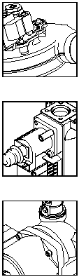

Contents
Section | Page
Legislation | 4
1.0 Introduction | 5
2.0 General Layout | 6
3.0 Appliance Operation | 7
4.0 Technical Data | 8
5.0 Dimensions and Fixings | 9
6.0 System Details | 10
7.0 Site Requirements | 13
8.0 Installation | 18
9.0 Commissioning the Boiler | 23
10.0 Completion | 25
11.0 Servicing the Boiler | 26
12.0 Changing Components | 28
13.0 Illustrated Wiring Diagram | 37
14.0 Fault Finding | 38
15.0 Short Parts List | 43
Page 3

IMPORTANT - Installation, Commissioning, Service & Repair
This appliance must be installed in accordance with the manufacturer's instructions and the regulations in force. Read the instructions fully before installing or using the appliance.
In GB, this must be carried out by a competent person as stated in the Gas Safety (Installation & Use) Regulations.
Definition of competence: A person who works for a CORGI registered company and holding current certificates in the relevant ACS modules, or valid ACoP equivalents, is deemed competent.
In IE, this must be carried out by a competent person as stated in I.S. 813 "Domestic Gas Installations".
Lifting - This product should be lifted and handled by two people. Stooping should be avoided and protective equipment worn where necessary. Carrying & lifting equipment should be used as required, e.g. when installing in a loft space.
The addition of anything that may interfere with the normal operation of the appliance without express written permission from the manufacturer or his agent could invalidate the appliance warranty. In GB this could also infringe the Gas Safety (Installation and Use) Regulations.
Warning - Check the information on the data plate is compatible with local supply conditions.
"Benchmark" Installation, Commissioning and Service Record Log Book
Please ensure that your installer has completed the Installation and Commissioning sections of the Log Book and hands the Log Book over. The details of the Log Book will be required in the event of any warranty work. Keep the Log Book in a safe place and ensure that the relevant sections are completed at each subsequent regular service visit.
All CORGI registered installers carry a CORGI identification card and have a registration number. Both should be recorded in your boiler Log Book. You can check your installer is registered by telephoning +44 (0)1256 372300 or writing to:-
1 Elmwood,
Chineham Business Park,
Crockford Lane,
Basingstoke. RG24 8WG

Legislation
Baxi declare that no substances harmful to health are contained in the appliance or used during appliance manufacture.
The appliance is suitable only for installation in GB and IE and should be installed in accordance with the rules in force, and only used in a suitably ventilated location.
In GB, the installation must be carried out by a CORGI Registered Installer. It must be carried out in accordance with the relevant requirements of the:
- Gas Safety (Installation & Use) Regulations.
- The appropriate Building Regulations either The Building Regulations, The Building Regulations (Scotland), Building Regulations (Northern Ireland).
- The Water Fittings Regulations or Water Byelaws in Scotland.
- The Current I.E.E. Wiring Regulations.
Where no specific instructions are given, reference should be made to the relevant British Standard Code of Practice.
In IE, the installation must be carried out by a competent Person and installed in accordance with the current edition of I.S. 813 'Domestic Gas Installations', the current Building Regulations and reference should be made to the current ETCI rules for electrical installation.
All systems must be thoroughly flushed and treated with inhibitor (see section 6.2).
Codes of Practice, most recent version should be used
In GB the following Codes of Practice apply:
Standard | Scope
BS 6891 | Gas Installation.
BS 5546 | Installation of hot water supplies for domestic purposes.
BS 5449 | Forced circulation hot water systems.
BS 6798 | Installation of gas fired hot water boilers.
BS 5440 Part 1 | Flues.
BS 5440 Part 2 | Ventilation.
BS 7074 | Expansion vessels and ancillary equipment for sealed water systems.
BS 7593 | Treatment of water in domestic hot water central heating systems.
In IE the following Codes of Practice apply:
Standard | Scope
I.S. 813 | Domestic Gas Installations.
The following BS standards give valuable additional information;
BS 5546 | Installation of hot water supplies for domestic purposes.
BS 5449 | Forced circulation hot water systems.
BS 7074 | Expansion vessels and ancillary equipment for sealed water systems.
BS 7593 | Treatment of water in domestic hot water central heating systems.
Page 4

1.0 Introduction

1.1 Description
1. The Baxi Combi 80Eco is a fully automatic gas fired wall mounted combination boiler. It is room sealed and fan assisted, and will serve central heating and mains fed domestic hot water.
2. The boiler is set to give a maximum output of 24.0 kW.
3. It is designed for use on Natural Gas (G20) and can be converted to use Propane or Butane.
4. The boiler is suitable for use only on fully pumped sealed heating systems. Priority is given to domestic hot water.
5. The boiler data badge gives details of the model, serial number and Gas Council number and is situated on the control box. It is visible when the case front panel is removed (Fig. 1).

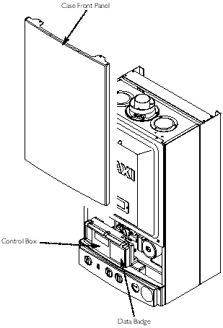
Fig. 1
6. The boiler is intended to be installed in residential / commercial / light industrial E.M.C. environments on a governed meter supply only.
7. The boiler must be installed with one of the purpose designed flues such as the standard horizontal flue kit, part no. 247719.
8. All systems must be thoroughly flushed and treated with inhibitor (see section 6.2).

1.2 Optional Extras
Various flue extensions, bends, vertical flue kits, control accessories etc. are available as optional extras. These are detailed in a separate publication.
Page 5

2.0 General Layout

2.1 Layout
- Air Pressure Switch
- Expansion Vessel
- Burner Manifold
- Automatic Air Vent
- DHW Plate Heat Exchanger
- Circulation Pump
- Drain Off Point
- Pressure Relief Valve
- Optional Integral Timer Position
- Central Heating System Pressure Gauge
- Control PCB
- Control Box
- 3-Way Valve Assembly
- Flame Sensing Electrode
- Spark Electrode
- Burner
- Primary Heat Exchanger
- Fan Assembly
- On / Off / Reset Selector Switch
- Burner On Neon
- Power On Neon
- Flame Failure Neon
- Central Heating Temperature Control
- Hot Water Temperature Control
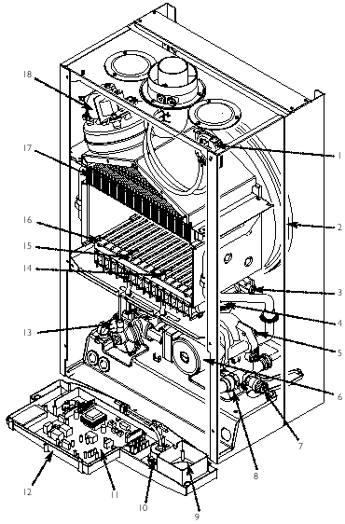
Fig. 2
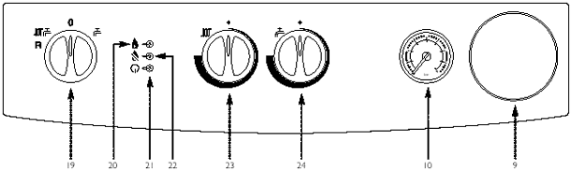
Fig. 3
Page 6

3.0 Appliance Operation
NOTE: All delay timers mentioned in 3.1 and 3.2 are overridden by domestic hot water demand.

3.1 Central Heating Mode (Fig. 4)

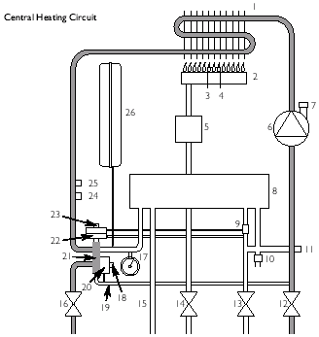
Fig. 4
Key
- Primary Heat Exchanger
- Burner
- Ignition Electrode
- Flame Sensing Electrode
- Gas Valve
- Pump
- Automatic Air Vent
- Plate Heat Exchanger
- Flow Sensor with Filter
- Pressure Relief Valve
- Boiler Drain Point
- Heating Return
- Cold Water Inlet On/Off Valve and Filter
- Gas Inlet
- Domestic Hot Water Outlet
- Heating Flow
- Pressure Gauge
- Hydraulic Differential Pressure Sensor Microswitch
- Automatic By-Pass
- Hydraulic Differential Pressure Sensor
- Diverter Valve Assembly
- Domestic Hot Water Flow Priority Assembly
- Domestic Hot Water Flow Priority Microswitch
- Temperature Sensor
- Overheat Thermostat
- Expansion Vessel
1. With a demand for heating, the pump circulates water through the primary circuit. At a pre-determined flow rate the central heating flow switch operates, initiating the ignition sequence.
2. The main burner ignites at low rate, then the gas valve controls the gas rate to maintain the heating temperature measured by the temperature sensor.
3. When the flow temperature exceeds the setting temperature, a 3 minute delay occurs before the burner relights automatically (anti-cycling). The pump continues to run during this period.

3.2 Domestic Hot Water Mode (Fig. 5)

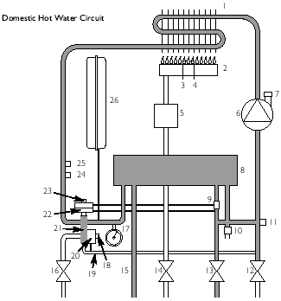
Fig. 5
1. Priority is given to the domestic hot water supply. A demand at a tap or shower will override any central heating requirement.
2. The flow of water will operate the DHW flow switch which requests the 3 way valve to change position. This will allow the pump to circulate the primary water through the DHW plate heat exchanger.
3. The burner will light automatically and the temperature of the domestic hot water is controlled by the temperature sensor.
4. When the domestic hot water demand ceases the burner will extinguish and the diverter valve will remain in the domestic hot water mode, unless there is a demand for central heating.
IMPORTANT: When the selector switch is in the '0' (Off) position the electrical supply to the boiler is isolated. The boiler will not operate and the integral timer (if fitted) will require resetting once the selector switch is turned to either the DHW or CH position.
Page 7

4.0 Technical Data
Appliance Type | C₁₂ | C₃₂
Appliance Category | CATII_{2H3+}

Heat Input C/H & DHW (Gross)
 | Max | Min
kW | 26.3 | 10.6
Btu/h | 89,739 | 36,167
Heat Output | Max | Min
kW | 24.0 | 9.3
Btu/h | 81,891 | 31,732
Max Gas Rate | (Natural Gas - G20)
 | (After 10 Mins)
m³/h | 2.78
ft³/h | 98.12
Burner Pressure | (Natural Gas - G20)
 | Max Rate | Min Rate
mbar | 12.2 ± 0.5 | 2.5 ± 0.2
in wg | 4.88 ± 0.2 | 1.0 ± 0.2
Inlet Pressure (Natural Gas - G20)
mbar | 20
in wg | 8
Burner Injector (Natural Gas - G20)
12 × 1.28mm Diameter

Electrical Supply | 230V~ 50H_{z}
(Appliance must be connected to an earthed supply)
Power Consumption | 170W
External Fuse Rating | 3A
Internal Fuse Rating
Fuse 2A Fast Blow to BS 4265
Electrical Protection
IPX4D

NO_{x} Class | 3
Flue Terminal | Diameter | 100mm
Dimensions | Projection | 95mm

Connections |  | copper tails
Gas Supply | - | 22mm
Central Heating Flow | - | 22mm
Central Heating Return | - | 22mm
Cold Water Mains Inlet | - | 15mm
DHW Flow | - | 15mm
Pressure Relief Discharge | - | 15mm
Outercase Dimensions
Casing Height | - | 780mm
Overall Height Inc Flue
Elbow | - | 980mm
Casing Width | - | 450mm
Casing Depth | - | 345mm

Clearances
Both Sides | 5 mm Min
Above Casing | 200 mm Min
Below Casing | 200 mm Min
Front | 450 mm Min (For Servicing)
Front | 5 mm Min (In Operation)

Weights | kg
Packaged Boiler Carton | 46
Packaged Flue Kit | 3
Installation Lift Weight | 38.5
Central Heating Primary Circuit
Pressures
 | bar
Safety Discharge | 3
Max Operating | 2.5
Min Operating | 0.5
Recommend Operating | 1-2
DHW Circuit | bar
Pressures
Max Operating | 8
Min Operating | 0.2
Min Operating Pressure at 9.8 l/min | 0.9
Flow Rates | l/min
DHW Flow Rate @ 30°C Rise | 11.4
DHW Flow Rate @ 35°C Rise | 9.8
Min Working DHW Flow Rate | 2.5

Pump
Available Head | See graph below

Expansion Vessel | - (For Central Heating only. Integral with appliance)
 |  | bar
Min Pre-charge Pressure |  | 0.5
 |  | litre
Max Capacity of CH System |  | 125
Primary Water Content of Boiler (unpressurised) |  | 1.0

Temperatures
C.H. Flow Temp (adjustable)
35°C to 85°C max (± 5°C)
D.H.W. Flow Temp (adjustable)
35°C to 65°C max (± 5°C) dependent upon flow rate
SEDBUK Declaration For Combi 80Eco
The seasonal efficiency (SEDBUK) is 78.6%
This value is used in the UK Government's Standard Assessment Procedure (SAP) for energy rating of dwellings. The test data from which it has been calculated have been certified by 0051.
LPG Gases - Propane G31 Butane G31
Burner Injector 12 × 0.77mm diameter
Burner Pressure |  | Max Rate | Min Rate
Propane | mbar | 36.2 | 6.4
 | in wg | 14.5 | 2.6
Butane mbar |  | 28.3 | 5.3
 | in wg | 11.3 | 2.1
Inlet Pressures |  | Butane | Propane
mbar |  | 28 | 37
in wg |  | 11.2 | 14.8
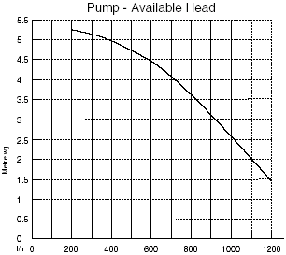
Page 8

5.0 Dimensions and Fixings
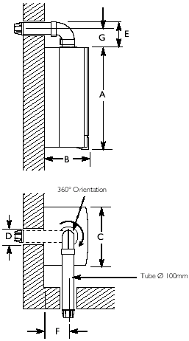
Dimensions
A | 780mm
B | 345mm
C | 450mm
D | 107mm Ø Min.
E | 200mm
F | 190mm
G | 143mm
Fig. 6
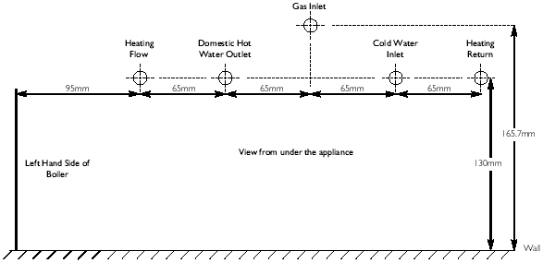
Fig. 7
Page 9

6.0 System Details

6.1 Information
1. The Baxi Combi 80Eco Combination Boiler is a 'Water Byelaws Scheme - Approved Product'.
To comply with the Water Byelaws your attention is drawn to the following installation requirements and notes (IRN).
a) IRN 001 - | See text of entry for installation requirements and notes.
b) IRN 302 - | Byelaw 14.
2. Reference to the WRC publications, 'Water fittings and materials directory' and 'Water supply byelaws guide' give full details of byelaws and the IRNs.

6.2 Central Heating Circuit
1. The appliance is suitable for fully pumped SEALED SYSTEMS ONLY.
Treatment of Water Circulating Systems
- All recirculatory water systems will be subject to corrosion unless an appropriate water treatment is applied. This means that the efficiency of the system will deteriorate as corrosion sludge accumulates within the system, risking damage to pump and valves, boiler noise and circulation problems.
- When upgrading existing systems that exhibit evidence of sludging, it is advisable to clean the system prior to treatment in order to remove any sludge and reduce the likelihood of these deposits damaging new components.
- When fitting new systems flux will be evident within the system, which can lead to damage of system components.
- All systems must be thoroughly drained and flushed out. The recommended flushing and cleansing agents are Betz-Dearborn Sentinel X300 or X400 and Fernox Superfloc Universal Cleanser which should be used following the flushing agent manufacturer's instructions.
- System additives - corrosion inhibitors and flushing agents/descalers should be suitable for aluminium and comply to BS7593 requirements. The only system additives recommended are Betz-Dearborn Sentinel X100 and Fernox-Copal which should be used following the inhibitor manufacturer's instructions.
Failure to flush and add inhibitor to the system may invalidate the appliance warranty.
- It is important to check the inhibitor concentration after installation, system modification and at every service in accordance with the manufacturer's instructions. (Test kits are available from inhibitor stockists.)
- For information or advice regarding any of the above contact Technical Enquiries.

6.3 Bypass
1. The boiler is fitted with an automatic integral bypass.

6.4 System Control
1. The boiler is designed for use in a heating system that incorporates external controls, i.e. a minimum of a timer device.
2. Suitable timer kits are available as optional extras.
3. For optimum operating conditions and maximum economy the fitting of a programmable thermostat is recommended.
Page 10

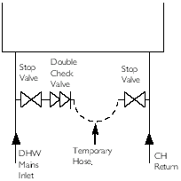
Fig. 8

6.5 System Filling and Pressurising
1. A filling point connection on the central heating return pipework must be provided to facilitate initial filling and pressurising and also any subsequent water loss replacement/refilling.
2. There are connection points on the mains cold water inlet and central heating return isolating taps to which the optional filling loop kit (Part No. 248221) can be assembled.
3. The filling method adopted must be in accordance with all relevant water supply regulations and use approved equipment.
4. Your attention is drawn to:
for GB: guidance G24.2 and recommendation R24.2 of the Water Regulations Guide.
for IE: the current edition of I.S. 813 "Domestic Gas Installations".
5. The sealed primary circuits may be filled or replenished by means of a temporary connection between the primary circuit and a supply pipe provided the arrangement in accordance with Diagram R24.2a of the Water Regulations Guide.
6. The temporary hose must be completely removed at both ends after use.

6.6 Expansion Vessel (Central Heating only)
1. The appliance expansion vessel is pre-charged to 0.5 bar. Therefore, the minimum cold fill pressure is 0.5 bar. The vessel is suitable for correct operation for system capacities up to 125 litres. For greater system capacities an additional expansion vessel must be fitted. For GB refer to BS 7074 Pt 1. For IE, the current edition of I.S. 813 "Domestic Gas Installations".

6.7 Pressure Relief Valve (Fig. 9)

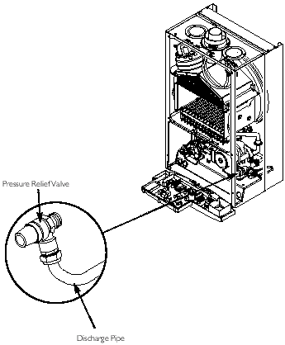
Fig. 9
1. The pressure relief valve is set at 3 bar, therefore all pipework, fittings, etc. should be suitable for pressures in excess of 3 bar.
2. The pressure relief discharge pipe should be not less than 15mm dia, run continuously downward, and discharge outside the building, preferably over a drain. It should be routed in such a manner that no hazard occurs to occupants or causes damage to wiring or electrical components. The end of the pipe should terminate facing down and towards the wall.
3. The discharge must not be above a window, entrance or other public access. Consideration must be given to the possibility that boiling water/steam could discharge from the pipe.
Page 11

6.8 Domestic Hot Water Circuit
1. All DHW circuits, connections, fittings, etc. should be fully in accordance with relevant standards and water supply regulations.
2. Your attention is drawn to:
for GB: Guidance G17 to G24 and recommendation R17 to R24 of the Water Regulations Guide.
for IE: the current edition of I.S. 813 "Domestic Gas Installations".
3. A single check valve must be fitted as shown in Fig. 11 to prevent backflow to the supply pipe and to ensure the efficient operation of the expansion vessel which is required to accommodate the thermal expansion of the water.

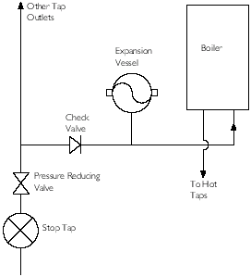
Fig. 11
4. When the domestic water system includes any device which prevents water expanding back towards the supply (check valve, loose jumpered stopcock, water meter, water treatment device) then an expansion vessel must be fitted (eg. Zilmet 160ml, R½ 15bar).
5. If the hot water expansion is not provided for, then high pressures can develop which may result in damage to fittings and devices on the system.
6. The boiler's maximum working mains pressure is 8 bar, therefore all pipework, connections, fittings, etc. should be suitable for pressures in excess of 8 bar. A pressure reducing valve must be fitted for pressures in excess of 8 bar. The manufacturer of any outlet fittings, such as a shower valve, may require a lower maximum pressure. The pressure reduction must take account of all fittings connected to the DHW system.

6.9 Showers
1. If a shower control is supplied from the appliance it should be of the thermostatic or pressure balanced type. Thermostatic type shower valves provide the best comfort and guard against water at too high a temperature. Existing controls may not be suitable - refer to the shower valve manufacturer.

6.10 Hard Water Areas
1. If the area of the installation is recognised as a HARD WATER AREA then a suitable device should be fitted to treat the mains water supply to the boiler. Contact your Water Distribution Company for advice on suitable devices.
Page 12

7.0 Site Requirements

7.1 Location
1. The boiler may be fitted to any suitable wall with the flue passing through an outside wall or roof and discharging to atmosphere in a position permitting satisfactory removal of combustion products and providing an adequate air supply. The boiler should be fitted within the building unless otherwise protected by a suitable enclosure i.e. garage or outhouse. (The boiler may be fitted inside a cupboard-see Section 7.3).
2. If the boiler is sited in an unheated enclosure then it is recommended to leave the ON/OFF Selector Switch in the domestic hot water and central heating position to give frost protection.
3. If the boiler is fitted in a room containing a bath or shower reference must be made to the relevant requirements.
In GB this is the current I.E.E. Wiring Regulations and Building Regulations.
In IE reference should be made to the current edition of I.S. 813 "Domestic Gas Installations" and the current ETCI rules.
4. If the boiler is to be fitted into a building of timber frame construction then reference must be made to the current edition of Institute of Gas Engineers Publication IGE/UP/7 (Gas Installations in Timber Framed Housing).

7.2 Clearances (Fig. 12 & 13)

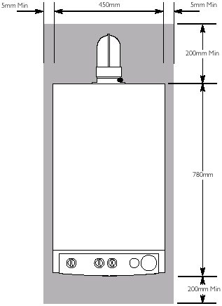
Fig. 12

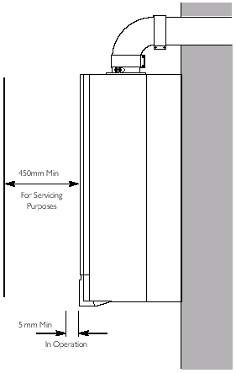
Fig. 13
1. A flat vertical area is required for the installation of the boiler.
2. These dimensions include the necessary clearances around the boiler for case removal, spanner access and air movement. Additional clearances may be required for the passage of pipes around local obstructions such as joists running parallel to the front face of the boiler.
Page 13

7.3 Ventilation of Compartments
1. Where the appliance is installed in a cupboard or compartment, no air vents are required. The appliance will run sufficiently cool without ventilation.
2. Minimum clearances must be maintained and the compartment should be large enough to house the boiler and any ancillary equipment only.

7.4 Gas Supply
1. The gas installation should be in accordance with the relevant standards. In GB this is BS 6891. In IE this is the current edition of I.S. 813 "Domestic Gas Installations".
2. The connection to the appliance is a 22mm copper tail located at the rear of the gas service cock (Fig. 14).

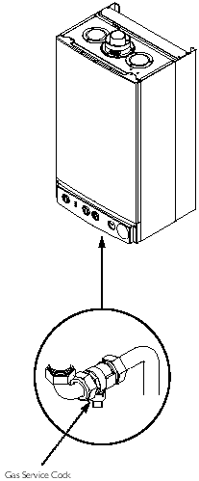
Fig. 14
3. Ensure that the pipework from the meter to the appliance is of adequate size. Do not use pipes of a smaller diameter than the boiler gas connection (22mm).

7.5 Electrical Supply
1. External wiring must be correctly earthed, polarised and in accordance with relevant regulations/rules. In GB this is the current I.E.E. Wiring Regulations. In IE reference should be made to the current edition of ETCI rules.
2. The mains supply is 230V ~ 50H_{z} fused at 3A.
NOTE: The method of connection to the electricity supply must facilitate complete electrical isolation of the appliance.
Connection may be via a fused double-pole isolator with a contact separation of at least 3mm in all poles and servicing the boiler and system controls only.
Page 14

7.6 Flue
1. The following guidelines indicate the general requirements for siting balanced flue terminals. For GB recommendations are given in BS 5440 PT.1. For IE recommendations are given in the current edition of I.S. 813 "Domestic Gas Installations".
2. If the terminal discharges onto a pathway or passageway, check that combustion products will not cause a nuisance and that the terminal will not obstruct the passageway.
3. If a terminal is less than 2 metres above a balcony, above ground or above a flat roof to which people have access, then a suitable terminal guard must be provided.
 | Terminal Position with Minimum Distance (Fig. 16) | (mm)
A* | Directly below an openable window, air vent or any other ventilation opening. | 300
B | Below gutter, drain/soil pipe. | 25
C | Below eaves. | 25
D | Below a balcony/car port roof. | 25
E | From vertical drain pipes and soil pipes. | 25
F | From internal or external corners. | 25
G | Above adjacent ground or balcony level. | 300
H | From a surface facing a terminal. | 600
I | Facing a terminals. | 1200
J | From opening (door/window) in carport into dwelling. | 1200
K | Vertically from a terminal on the same wall. | 1500
L | Horizontally from a terminal on the same wall. | 300
M* | Above an opening, air brick, opening window etc. | 300
N* | Horizontally to an opening, air brick, opening window etc. | 300
* In addition, the terminal should be no nearer than 150mm to an opening in the building fabric formed for the purpose of accommodating a built-in element such as a window frame. See BS 5440 Pt. 1.

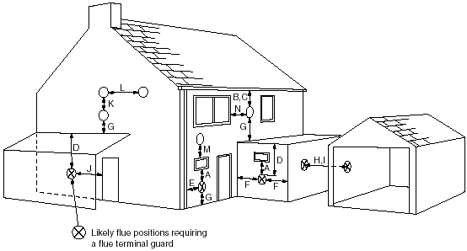
Fig. 16
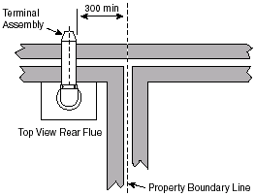
Page 15

7.7 Flue Dimensions
The standard horizontal flue kit allows for flue lengths between 100mm and 1 metre from elbow to terminal (Fig. 17).

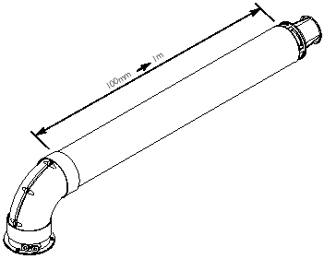
Fig. 17
The maximum permissible equivalent flue length is: 5 metres.
NOTE: Each additional 45° of flue bend will account for an equivalent flue length of 0.5m.
eg. 45° = 0.5m, 90° = 2 × 45° = 1m etc.

7.8 Flue Terminal Trim
1. Once the flue is secure the trim can be fitted if required.
2. Remove the protective backing from the adhesive seal. Apply the seal to the rear of the trim flange (Fig. 18).

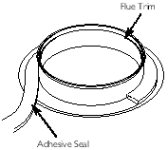
Fig. 18
3. Locate the trim over the flue terminal and push it back to the wall to compress the seal (Fig. 19).

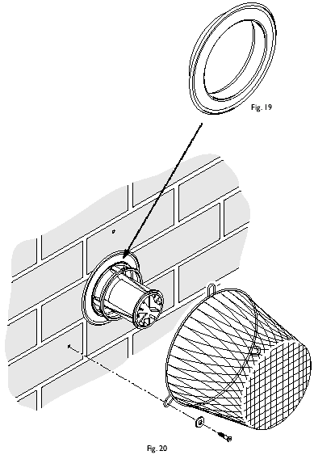

7.9 Terminal Guard (Fig. 20)
1. When codes of practice dictate the use of terminal guards, they can be obtained from most Plumbers' and Builders' Merchants.
2. There must be a clearance of at least 50mm between any part of the terminal and the guard.
3. When ordering a terminal guard, quote the appliance model number.
4. The flue terminal guard should be positioned centrally over the terminal and fixed as illustrated.
Page 16

7.10 Flue Options
1. The Baxi Combi 80Eco can be fitted with flue systems as illustrated.
2. The standard flue is suitable only for horizontal applications.
3. Maximum permissible equivalent flue lengths are:-
Horizontal | 5 metres
Vertical | 4 metres
Vertical (Twin Pipe) | 15 metres
4. Any additional "in line" bends in the flue system must be taken into consideration.
Their equivalent lengths are:-
Concentric Pipes:
 | 45° bend | 0.5 metres
 | 90° bend | 1.0 metres
Twin Flue Pipe
 | 45° bend | 0.25 metres
 | 90° bend | 0.50 metres
The elbow supplied with the standard horizontal flue is not included in any equivalent length calculations
5. The illustrations opposite show examples of maximum equivalent lengths.
6. Full details of part numbers and descriptions of all optional flue components and kits can be found in the Baxi Flue Guide.
7. Instructions for guidance and fitting are included in each kit where appropriate.
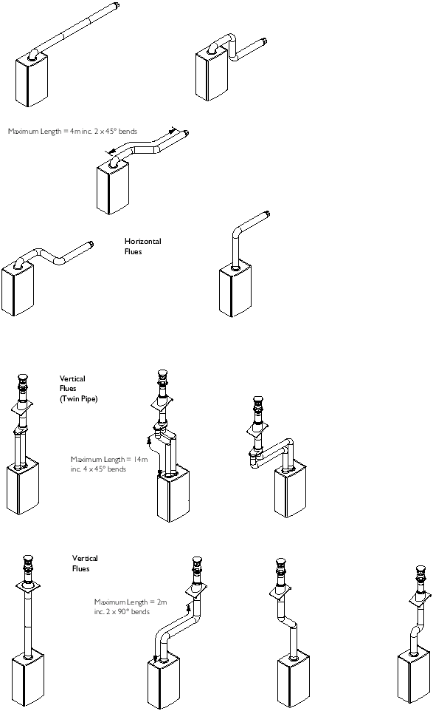
Page 17

8.0 Installation

8.1 Initial Preparation
The gas supply, gas type and pressure must be checked for suitability before connection (see Section 7.4).
1. After considering the site requirements (see Section 7.0) position the fixing template on the wall ensuring it is level both horizontally and vertically.
2. Mark the position of the two most suitable fixing slots for the wall plate and boiler lower fixing holes. It is preferable to use the horizontal fixing slots. For side flue exit, mark as shown.
3. Mark the position of the centre of the flue hole (rear exit). For side flue exit, mark as shown.
4. If required, mark the position of the gas and water pipes. Remove the template.
5. Cut the hole for the flue (minimum diameter 107mm).
6. Drill the wall as previously marked to accept the wall plugs supplied. Secure the wall plate using two of the fixing screws.
7. Using a spirit level ensure that the plate is level before finally tightening the screws.

8.2 Flushing
1. Insert a tube into the central heating flow or return pipe (Fig. 22).

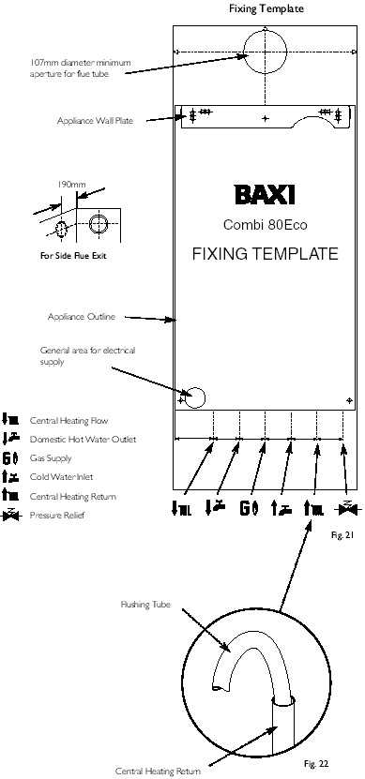
2. Flush thoroughly (see System Details, Section 6.2).

8.3 Preparing The Boiler
1. Remove all packaging.
2. Stand the boiler on its base by using the rear lower edge as a pivot.
NOTE: A small amount of water may drain from the boiler in the upright position.
Page 18

8.4 Fitting The Boiler
1. Lift the boiler using the lower edges. Engage the slots at the top rear of the boiler on the wall plate hooks (Fig. 23).

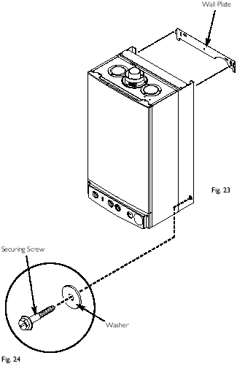
2. Ensure that the boiler is level and sits against the wall.
3. Take the two steel washers and remaining screws. Using the previously drilled and plugged holes, secure the bottom of the boiler to the wall (Fig. 24).
4. Remove the elbows, valves and sealing washers from the packaging. The ¾ in valve with internal filter must be fitted to the central heating return. The filter is visible through the branch connection of the valve.
5. Using the sealing washers provided connect the valves to the heating flow and return, and the cold water inlet.
6. Connect the elbows to the gas service cock and hot water outlet pipe, and then connect the elbows to the boiler. Connect the elbows with flared ends to the valves.
7. Ensure that the sealing washers are used on all connections. The rubber washers must be used on the gas connections.
8. The gas and water supplies, central heating flow and return and domestic hot water flow can now be connected.

8.5 Fitting the Pressure Relief Discharge Pipe (Fig. 25)

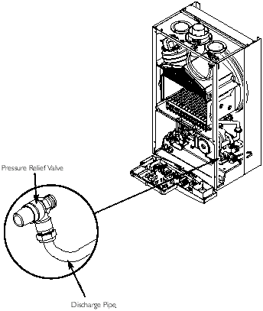
Fig. 25
1. Remove the discharge pipe from the kit.
2. Determine the routing of the discharge pipe in the vicinity of the boiler. Make up as much of the pipework as is practical, including the discharge pipe supplied.
3. The pipework must be at least 15mm diameter and run continuously downwards to a discharge point outside the building (Fig. 26). See section 6.7 for further details.
4. Utilising one of the sealing washers, connect the discharge pipe to the adaptor and tighten the nut.
5. Complete the discharge pipework and route it to the outside discharge point.
IMPORTANT: Make all soldered joints before connecting to the pressure relief valve.
Page 19

8.6 Fitting The Flue
HORIZONTAL FLUE
1. The standard flue is suitable for lengths 100mm minimum to 1m maximum (measured from the edge of the flue elbow outlet).
Rear Flue: maximum wall thickness - 900mm
Side Flue: maximum wall thickness - 870mm
2. Locate the flue elbow on the adaptor at the top of the boiler. Set the elbow to the required orientation (rear, right or left).
3. Measure the distance from the outside wall face to the elbow (Fig. 27). This dimension will be known as 'X'.

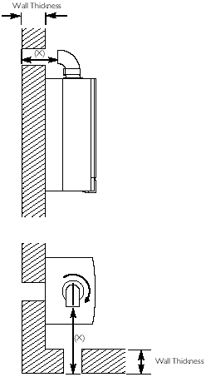
Fig. 27
4. Taking the air duct, mark dimension 'X' as shown (Fig. 28). Measure the length of waste material, and transfer the dimension to the flue duct (Fig. 28).

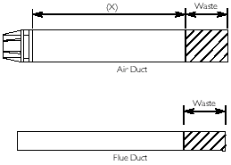
Fig. 28
5. Remove the waste from both ducts. Ensure that the cut ends are square and free from burrs.
6. Remove the flue elbow from the adaptor.
IMPORTANT: Check all measurements before cutting.
Page 20

IMPORTANT: If the equivalent flue length is greater than 1.5m the restrictor MUST be removed from the adaptor (Fig. 29).

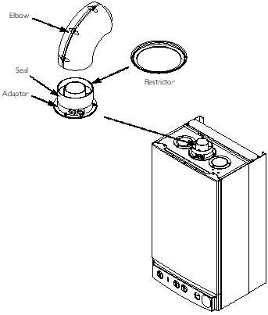
Fig. 29
7. Insert the flue duct into the air duct and pass them through the hole in the wall.
8. Take one of the rubber seals and position it on the boiler flue adaptor. Engage the flue elbow on the adaptor and pull the sleeve up so that it equally covers the joint (Fig. 29).
9. Remove the screws from one of the clips provided. Prise the clip apart and fit it over the seal. Set the elbow to the required angle (Fig. 30).

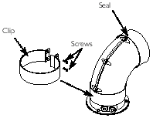
Fig. 30
10. Refit the screws to the clip and tighten them to secure the elbow. Take the second rubber seal and position it on the flue elbow.
11. Locate the flue duct clamp on the flue outlet elbow. Draw the flue duct out of the air duct, engage it in the clamp and tighten the screws (Fig. 31).

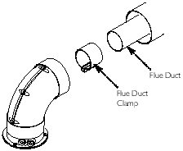
Fig. 31
12. Draw the air duct out of the wall and align it with the elbow. Position the seal so that it equally covers the joint (Fig. 32).

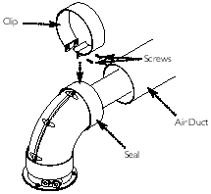
Fig. 32
13. Remove the screws from the second clip provided. Prise the clip apart and fit it over the seal. Refit the screws to the clip and tighten them (Fig. 32).
14. Where possible position the clips so that the screws are not visible.
15. Make good between the wall and air duct outside the building.
16. Fit the circular flue trim outside if required, and if necessary fit a terminal guard (see Section 7.8 & 7.9).
VERTICAL FLUE
1. Only a flue approved with the Baxi Combi 80Eco can be used.
2. For information on vertical flues consult the Baxi Flue Guide Brochure or Notes for Guidance supplied with the vertical flue pack.
Page 21

8.7 Making The Electrical Connections
To connect the mains input cable proceed as follows:-
1. Slacken the facia securing screws and lift the outercase panel so that it's securing tabs are clear of the facia. Remove the panel.
2. Remove the screws securing the facia panel and hinge it down (Fig. 35).

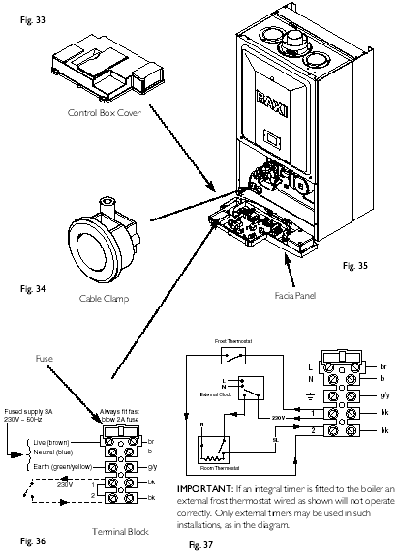
3. Remove the control box cover securing screws. Disengage the barbs on the control box from the cover. Remove the cover (Fig. 33).
4. Slacken the cable clamp on the LH side of the boiler chassis. Insert the cable through the clamp and route it to the terminal block (Fig. 34).
5. Slacken the screws in the terminal block, connect the input cable, and tighten the screws.
6. If an external control is to be connected it can be done at this point. Run the input cable from the external control through the second cable clamp on the boiler chassis. Refer to the instructions supplied with the control.
7. Remove the link between terminal 1 and 2 and connect the wiring from the external control (Figs. 36 & 37).
NOTE: If the room thermostat being used incorporates an anticipator it MUST be wired as shown in Fig. 37.

IMPORTANT: The external control MUST be suitable for 230V switching.
8. Ensure that both mains input and, where fitted, external control input cables have sufficient slack to allow the control box to drop down. Tighten the cable clamp(s) on the boiler chassis.
9. If the optional integral timer is to be used it should be fitted at this point. Refer to the instructions supplied with the timer. NOTE: An external frost thermostat cannot be used with the integral timer.

8.8 Preliminary Electrical Checks
1. Prior to commissioning the boiler preliminary electrical system checks should be carried out.
2. These should be performed using a suitable meter, and include checks for Ground Continuity, Resistance to Ground, Short Circuit and Polarity.
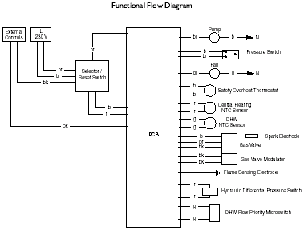
Key to Wiring
b - blue
br - brown
bk - black
r - red
g - green
w - white
Fig. 38
Page 22

9.0 Commissioning the Boiler

9.1 Commissioning the Boiler
1. Reference should be made to BS 5449 Section 5 when commissioning the boiler.
2. Open the mains water supply to the boiler.
3. Open all hot water taps to purge the DHW system.
4. Ensure that the filling loop is connected and open, then open the heating flow and return valves on the boiler.
5. Open the screw on the automatic air vent (Fig. 40).

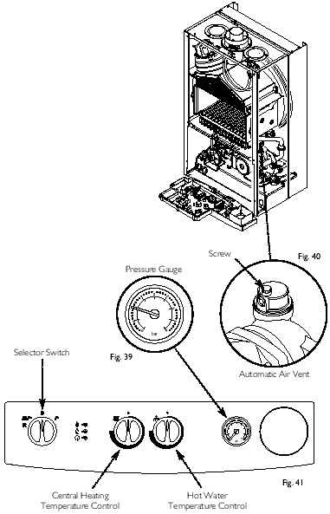
6. The system must be flushed in accordance with BS 7593 (see Section 6.2) and the flushing agent manufacturers instructions.
7. Pressurise the system to 1.0 bar then close and disconnect the filling loop (Fig. 39).
8. Turn the gas supply on and purge according to in GB BS 6891 and in IE I.S. 813 "Domestic Gas Installations".
9. Test for gas soundness.
10. If at any time during commissioning it is required to terminate a particular cycle, turn the selector to the OFF position and then back to either () or () (Fig. 41).
Page 23

9.2 Checking the Burner Pressure
1. Turn on the gas and electrical supplies to the boiler and ensure that all external controls are calling for heat.
2. Set the temperature controls to maximum and the selector switch to the Off position (Fig. 42).

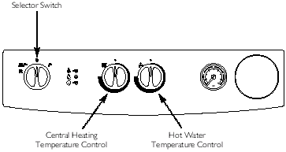
Fig. 42
3. Slacken the pressure test point sealing screw on the gas valve and connect a pressure gauge (Fig. 43).

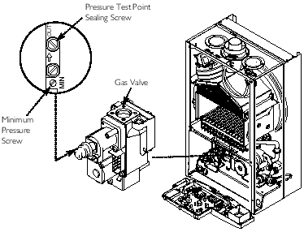
Fig. 43
4. Undo the screws securing the inner door panel. Lift the panel slightly to disengage it from the studs on top of the case.
5. IMPORTANT: Turn the selector switch fully anticlockwise against the spring pressure to the reset position (R) and hold for at least 3 seconds to reset the boiler.
6. Turn the selector switch to the Cental Heating and Domestic Hot Water position (). The power On neon () will illuminate (Fig. 42).
7. Turn a hot water tap on to give a flow rate of at least 10l/min.
8. The pressure should be as quoted in Section 4.0 Technical Data. If not, check that the gas supply pressure is correct (Natural Gas 20mbar, Butane 30mbar and Propane 37mbar).
9. The pressure can be adjusted if required.
10. To check and set minimum pressure first remove one of the modulator wires.
Adjusting the Pressure (Fig 44)

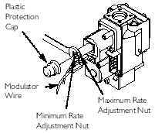
NOTE: Gas Valve Electrical Plug shown removed for clarity.
Fig. 44
11. Remove the plastic protection cap from the pressure adjustment nuts on the valve.
12. The smaller nut (5mm) adjusts minimum pressure and the larger nut (8mm) maximum pressure.
13. Using a suitable spanner adjust the relevant nut until the correct pressure is achieved.
14. Once the pressure has been set turn the boiler off and disconnect the pressure gauge.
15. Tighten the pressure test screw and refit the modulator to the valve. Reassemble in reverse order.
Page 24

10.0 Completion

10.1 Completion
1. Hinge the facia panel upwards and refit the case front panel. Secure them with the screws previously removed (Fig. 45).

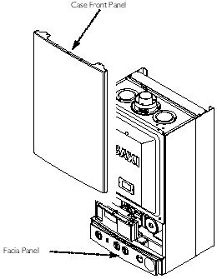
Fig. 45
2. Instruct the user in the operation of the boiler and system, explaining the operational sequence.
3. Carefully read and complete all sections of the "Benchmark" Installation, Commissioning and Service Record Log Book that are relevant to the appliance and installation. The details of the Log Book will be required in the event of any warranty work. The Log Book must be handed to the user for safe keeping and each subsequent regular service visit recorded.
4. For IE, it is necessary to complete a "Declaration of Conformity" to indicate compliance with I.S. 813. An example of this is given in I.S. 813 "Domestic Gas Installations". In addition it is necessary to complete the "Benchmark" Log Book.
5. Hand over the Users Operating, Installation and Servicing Instructions and the Log Book, giving advice on the necessity of regular servicing.
Page 25

11.0 Servicing the Boiler

11 .1 Annual Servicing
1. For reasons of safety and economy, it is recommended that the boiler is serviced annually. Servicing must be performed by a competent person.
2. After servicing, complete the relevant section of the "Benchmark" Installation, Commissioning and Service Record Log Book. This should be in the possession of the user.
3. Ensure that the boiler is cool.
4. Ensure that both the gas and electrical supplies to the boiler are isolated.
5. Slacken the screws securing the facia panel. Lift the outercase panel so that its securing tabs are clear of the facia. Remove the panel (Fig. 47).

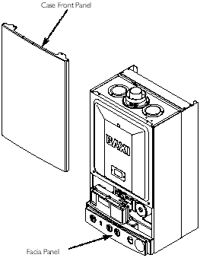
Fig. 47
6. Remove the screws securing the inner door panel. Lift the panel slightly to disengage it from the studs on top of the case (Fig. 48).

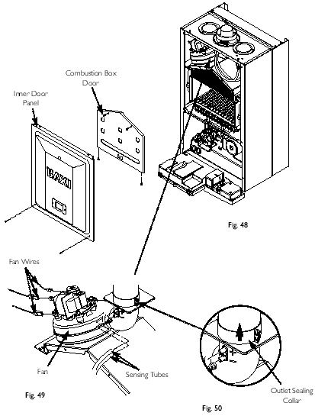
7. Note the positions of the two sensing tubes on the outlet elbow and three wires on the fan motor and remove them (Fig. 49).
8. Slacken the screws on the outlet sealing collar. Ease the collar upwards as far as possible (Fig. 50).
9. Remove the four screws securing the combustion box door and remove the door (Fig. 48).
Page 26

10. Remove the spring clips retaining the air box side baffle plates. Disengage the tabs on the baffles from the slots in the fan hood (Fig. 52).

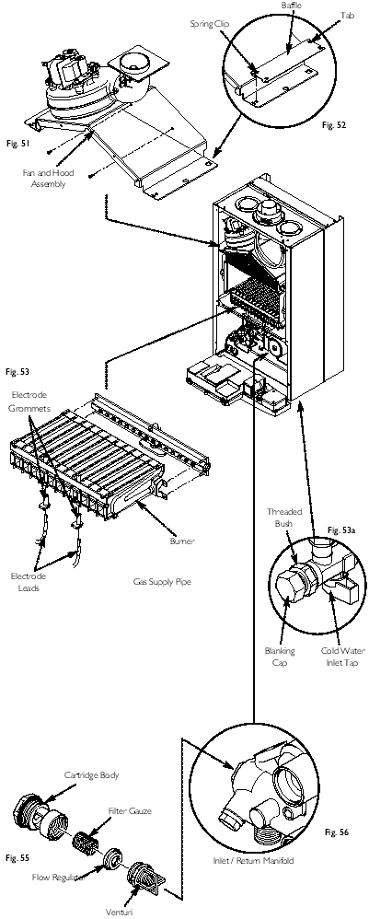
11. Undo the screws securing the fan hood assembly to the appliance back panel, and draw the fan and hood assembly forwards (Fig. 51).
12. Draw the burner out of the combustion box, pulling the electrode grommets from the slots in the combustion box lower panel (Fig. 53).
13. Disconnect the electrode leads and grommets from the electrodes. Completely remove the burner (Fig. 53).
14. Brush any deposits from the injectors. Do not use a pin or wire to clean them.
15. Brush the burner blades and venturis and clean the combustion box.
16. Ensure that the heat exchanger fins are clear of any obstruction.
D.H.W. Filters
17. If the flow of domestic hot water is diminished, it may be necessary to clean the filters.
18. Initially check the cold water inlet tap filter.
19. Turn the tap off. Undo the blanking cap and remove the threaded bush (Fig. 53a).
20. Extract the filter and rinse thoroughly in clean water. Reassemble and check the flow. If required clean the manifold filter as described below.
21. Undo the filter cartridge from the inlet/return manifold (Fig. 56).
22. Dismantle the cartridge and carefully remove the flow regulator and filter gauze. Rinse them thoroughly in clean water and reassemble in reverse order (Fig. 55).
23. Check that the pressure vessel charge is 0.5bar, reassemble in reverse order of dismantling and recommission.
24. Turn the selector switch fully anticlockwise against the spring pressure to the reset position (R) and hold for at least 3 seconds to reset the boiler.
25. Complete the relevant section of the "Benchmark" Installation, Commissioning and Service Record Log Book and hand it back to the user.
Page 27

12.0 Changing Components
IMPORTANT: When changing components ensure that both the gas and electrical supplies to the boiler are isolated before any work is started. When the new component has been fitted turn the selector switch fully anticlockwise against the spring pressure to position R and hold for at least 3 seconds to reset the boiler before recommissioning.
See Section 11.1 "Annual Servicing" for removal of case panel, door etc.

12.1 Pressure Switch
1. Note the positions of the two sensing tubes and wires and remove them (Fig. 57).

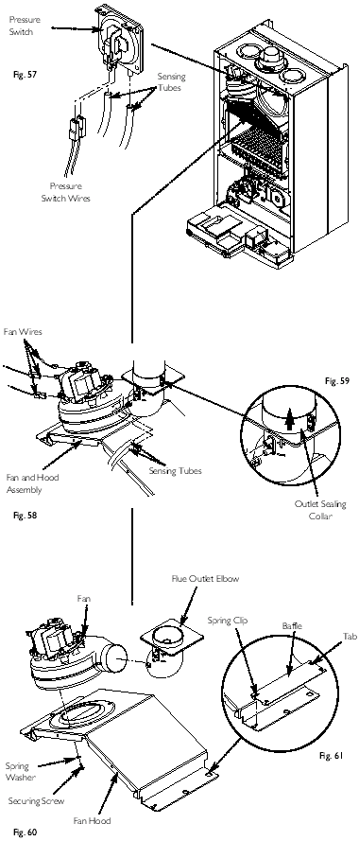
2. Remove the two screws holding the pressure switch to the combustion box top panel.
3. Fit the new pressure switch and reassemble all components in reverse order of dismantling.

12.2 Fan
1. Note the positions of the two sensing tubes on the outlet elbow and three wires on the fan motor and remove them (Fig. 58).
2. Slacken the screws on the outlet sealing collar. Ease the collar upwards as far as possible (Fig. 59).
3. Remove the four screws securing the combustion box door and remove the door.
4. Remove the spring clips retaining the air box side baffle plates. Disengage the tabs on the baffles from the slots in the fan hood (Fig. 61).
5. Undo the screws securing the fan hood to the appliance back panel, and draw the fan and hood assembly forwards (Fig. 60).
6. Remove the screws and spring washers securing the fan to the hood. Transfer the flue outlet elbow to the new fan (Fig. 60).
7. Fit the new fan to the hood using the screws and spring washers previously removed.
8. Reassemble in reverse order of dismantling.
Page 28

12.3 Heat Exchanger (Fig. 62)

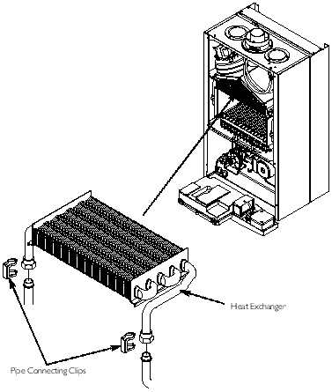
Fig. 62
1. Note the positions of the two sensing tubes on the outlet elbow and three wires on the fan motor and remove them (Figs. 58 to 61).
2. Slacken the screws on the outlet sealing collar. Ease the collar upwards as far as possible.
3. Remove the four screws securing the combustion box door and remove the door.
4. Remove the spring clips retaining the air box side baffle plates. Disengage the tabs on the baffles from the slots in the fan hood.
5. Undo the screws securing the fan hood to the appliance back panel, and draw the fan and hood assembly forwards.
6. Drain the primary circuit. Prise the two pipe connecting clips off the joints in the flow and return pipes.
7. Lift the heat exchanger to disconnect the flow and return pipe joints. Withdraw it from the appliance, taking care not to damage the rear insulation piece.
8. Fit the new heat exchanger, ensuring that the tabs on the side insulation carriers engage in the slots in the heat exchanger side plates.
9. Reassemble in reverse order of dismantling, and repressurise the system.

12.4 Burner (Fig. 63)

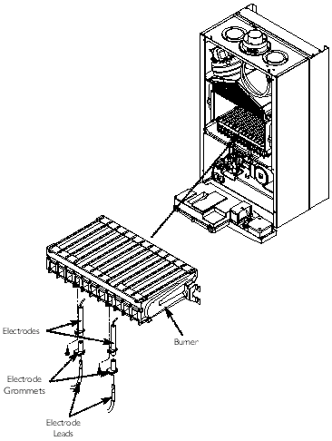
Fig. 63
1. Remove the four screws securing the combustion box door and remove the door.
2. Draw the burner out of the combustion box, pulling the electrode grommets from the slots in the combustion box lower panel.
3. Disconnect the electrode leads and grommets from the electrodes. Completely remove the burner.
4. Undo the screws securing the electrodes to the burner. Examine the condition of the electrodes, replacing if necessary. Fit the electrodes to the new burner.
5. Engage the burner location brackets over the studs on the injector manifold and reassemble in reverse order.
Page 29

12.5 Injectors (Fig. 64)

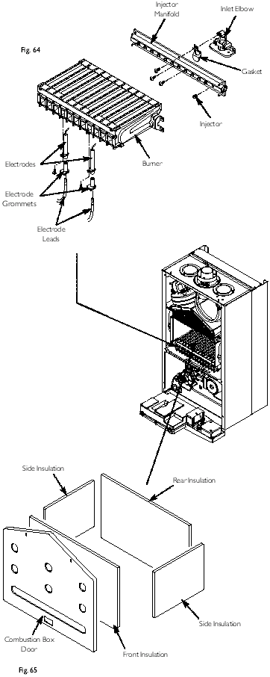
1. Remove the burner as described in Section 12.4.
2. Undo the screws securing the injector manifold to the inlet elbow and remove the manifold.
3. Unscrew and replace injectors as required and examine the sealing gasket, replacing as necessary. Reassemble in reverse order.

12.6 Electrodes (Fig. 64)
1. Remove the four screws securing the combustion box door and remove the door.
2. Draw the burner out of the combustion box, pulling the electrode grommets from the slots in the combustion box lower panel.
3. Disconnect the lead and grommet from the electrode being replaced. Undo the securing screw and withdraw the electrode to the burner.
4. Reassemble in reverse order.

12.7 Insulation (Fig. 65)
1. Remove the four screws securing the combustion box door and remove the door.
2. Slide the side insulation pieces carefully out of their carriers.
3. To replace the rear insulation piece it is necessary to remove the heat exchanger as described in Section 12.3 and slide out the side pieces.
4. The combustion box door insulation piece can be replaced by carefully bending up the two retaining tabs.
5. Replace all insulation pieces and reassemble in reverse order.
Page 30

12.8 Gas Valve (Fig. 66)

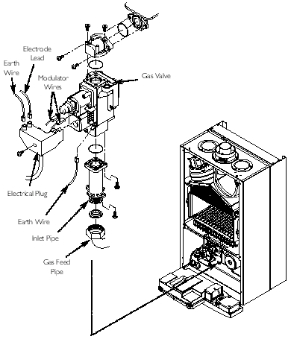
Fig. 66
1. Undo the nut on the gas feed pipe at the tap rail under the boiler.
2. Completely undo the securing screws and hinge the facia panel down.
3. Disconnect the earth wire and pressure sensing pipe from the valve. Undo the screw securing the electrical plug to the valve and disconnect the plug.
4. Pull the earth wire off the spade terminal on the valve.
5. Remove the screws securing the inlet pipe flange to the tap rail and those securing the outlet manifold to the burner manifold.
6. Remove the valve from the boiler.
7. Note the orientation of the inlet pipe and outlet manifold. Undo the securing screws and remove the pipe and manifold.
8. Examine the 'O' ring seals for damage, replacing as necessary.
9. Fit the inlet pipe and outlet manifold to the new valve, ensuring that the 'O' ring seals are in place.
10. Reassemble in reverse order and check the burner pressure (Section 9.2).

12.9 Temperature Sensor (Fig. 67)

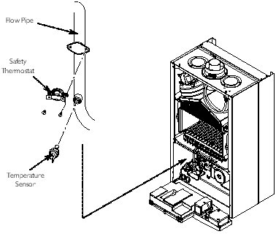
Fig. 67
1. Ease the retaining tab on the sensor away and disconnect the electrical plug.
2. Unscrew the sensor from it's pocket and reassemble in reverse order. The plug will only fit one way.

12.10 Safety Thermostat (Fig. 67)
1. Pull the two electrical connections off the thermostat.
2. Remove the screws securing the thermostat to the mounting plate on the flow pipe.
3. Reassemble in reverse order. The thermostat is not polarised - either wire can fit either terminal on the thermostat.
Page 31

12.11 Pump - Head Only (Figs. 68 & 69)

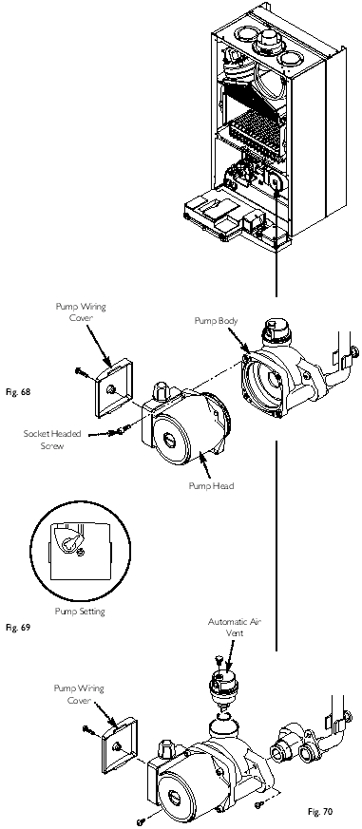
1. Drain the primary circuit and remove the socket head screws securing the pump head to the body and draw the head away.
2. Undo the screw on the pump wiring cover and remove the cover. Using a suitable flat bladed screw driver press the cable securing levers downwards to release each wire after noting their position.
3. A standard Grundfos 15-50 replacement head can now be fitted. Connect the wiring to the new head. The pump speed must be set to 3.
4. Reassemble in reverse order.

12.12 Pump - Complete (Figs. 69 & 70)
1. Drain the primary circuit and unscrew the automatic air vent from the pump body. Undo the two screws securing the body to the pipe and manifold and draw the pump forwards.
2. Undo the screw on the pump wiring cover and remove the cover. Using a suitable flat bladed screw driver press the cable securing levers downwards to release each wire after noting their position.
3. Connect the wiring to the new pump. Examine the 'O' ring seals on the return pipe and manifold, replacing if necessary.
4. Fit the air vent to the pump body and reassemble in reverse order.

12.13 Automatic Air Vent (Fig. 70)
1. Drain the primary circuit and unscrew the automatic air vent from the pump body.
2. Examine the 'O' ring seal, replacing if necessary, and fit it to the new automatic air vent.
3. Reassemble in reverse order.
Page 32

12.14 Pressure Gauge
1. Drain the primary circuit and undo the nut on the pressure gauge capillary (Fig. 71).

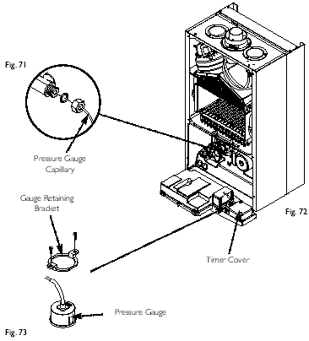
2. Remove the timer cover and ease the timer wiring aside. Undo the screws securing the gauge retaining bracket (Fig. 72).
3. Remove the bracket and gauge assembly. Depress the barbs on the side of the gauge and remove the retaining bracket (Fig. 73).
4. Reassemble in reverse order.

12.15 Expansion Vessel
1. To replace the expansion vessel it is necessary to remove the boiler from the wall.
NOTE: Alternatively a vessel of equivalent capacity can be fitted on the system return pipe as close as possible to the boiler.
2. Drain the system and undo all gas and water connections. Remove the flue elbow.
3. Lift the boiler off the wall bracket and lay it on it's side on a clean flat surface.
4. Undo the nut on the vessel outlet spigot, and remove the locknut and spring washer securing the spigot to the boiler chassis (Fig. 74).

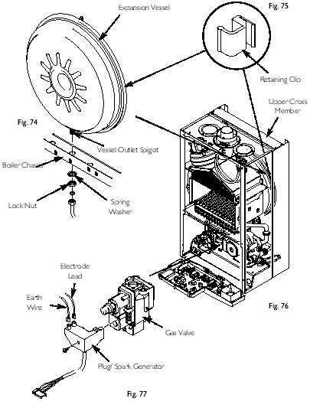
5. Undo the screws and remove the appliance upper cross member (Fig. 76). Slide the expansion vessel out of the retaining clips (Fig. 75).
6. Reassemble in reverse order. Fully recommission the appliance and system.

12.16 Gas Valve Plug/Spark Generator (Fig. 77)
1. The valve electrical plug, spark generator and lead are combined in one unit.
2. Disconnect the earth wire and electrode lead from the plug/generator. Undo the screw securing the plug/generator to the valve and disconnect it.
3. Remove the screws securing the control box cover and release the cover retaining barbs from their slots. Disengage the rear tabs of the cover from the control box hinge pin.
4. Remove the plug lead from the cable clip and disconnect the multi-pin plug from the PCB.
5. Reassemble in reverse order.
Page 33

12.17 Pressure Relief Valve (Fig. 78)

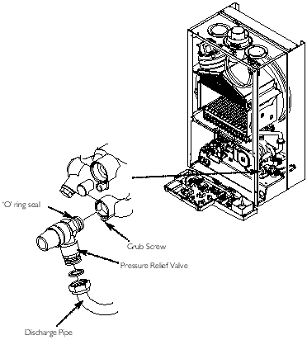
Fig. 78
1. Drain the primary circuit.
2. Disconnect the discharge pipe from the valve. Using a suitable hexagon key slacken the grub screw sufficiently to release the valve.
3. Note the orientation of the valve, rotate it and withdraw it from the manifold.
4. Fit the new valve and 'O' ring seal and set to the previously noted orientation. Reassemble in reverse order.

12.18 P.C.B.
1. Note the settings of the temperature control knobs. Rotate the knobs fully anticlockwise and carefully pull them off the drive pins (Fig. 80).

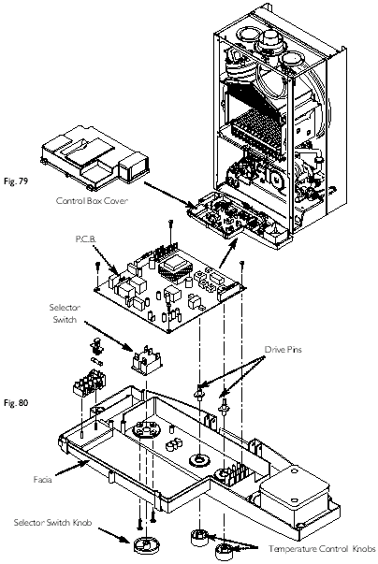
2. Remove the screws securing the control box cover and release the cover retaining barbs from their slots. Disengage the rear of the cover from the control box hinge pin (Fig. 79).
3. Note the position of all plugs and wires on the P.C.B. and disconnect them. Pull the drive pins off the P.C.B.
4. Undo the securing screws and remove the P.C.B.
5. Reassemble in reverse order, ensuring that the temperature controllers are reset to their previous positions (Fig. 80).
6. IMPORTANT: Turn the selector switch fully anticlockwise against the spring pressure to the reset position (R) and hold for at least 3 seconds to reset the boiler.

12.19 Selector Switch
1. Note the setting of the selector switch knob and carefully pull it off the facia (Fig. 80).
2. Remove the screws securing the control box cover and release the cover retaining barbs from their slots. Disengage the rear of the cover from the control box hinge pin (Fig. 79).
3. Note the position of the electrical connections and the orientation of the switch. Remove the electrical connections.
4. Remove the screws securing the switch to the facia panel (Fig. 80).
5. Fit the new switch, ensuring that it is correctly positioned and reassemble in reverse order.
Page 34

12.20 Plate Heat Exchanger (Fig. 81)

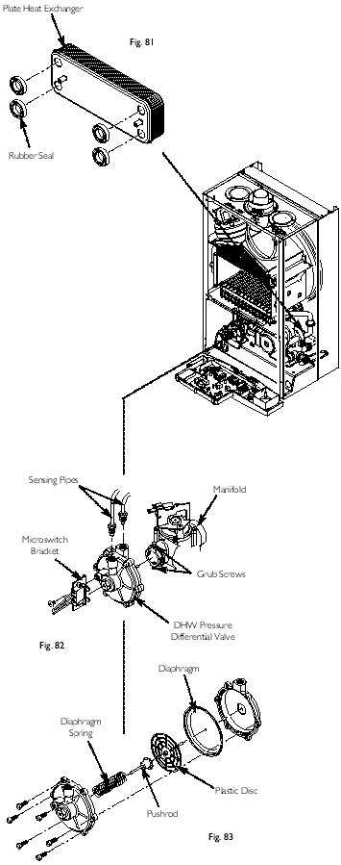
1. Drain the primary circuit.
2. While supporting the heat exchanger undo the screws securing it to the brass manifolds.
3. Withdraw the heat exchanger upwards and to the left of the gas valve, taking care not to damage any wires or controls.
Seals
4. There are four rubber seals between the manifolds and heat exchanger which may need replacement.
5. Ease the seals out of the manifold. Replace carefully, ensuring that the seal is inserted into the manifold parallel and pushed fully in.
6. When fitting the new heat exchanger note that the left hand location stud is offset towards the centre more than the right hand one.
7. Reassemble in reverse order.

12.21 Diverter Valve Assembly (Fig. 82)
The diverter valve assembly comprises of a central heating pressure differential valve and a domestic hot water pressure differential valve. These are connected to a manifold which is joined to the plate heat exchanger.
DHW Pressure Differential Valve (Fig. 83)
1. Drain the primary circuit.
2. Undo the screw securing the microswitch bracket to the valve (Fig. 82).
3. Disconnect the two sensing pipes and slacken the grub screws securing the valve to the diverter manifold.
4. Draw the valve away from the diverter manifold. The valve may now be replaced or split to examine the diaphragm.
5. To examine the diaphragm hold the valve body securely and carefully remove the six screws. The diaphragm spring will force apart the two halves of the valve.
6. Remove the plastic disc and pushrod assembly. Carefully examine the diaphragm and replace it if there is any damage.
7. Reassemble in reverse order.
Page 35

Pressure Differential Valve (Fig. 84)

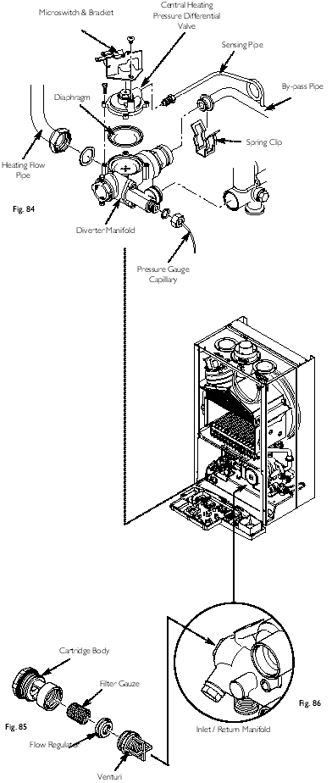
1. Remove the pressure differential valve as described above.
2. From the brass diverter manifold undo the nut on the heating flow pipe. Remove the screw securing the diverter manifold to the appliance lower bracket.
3. Disconnect the pressure gauge capillary from the diverter manifold and remove the two wires from the microswitch.
4. Prise off the spring clip securing the by-pass pipe to the diverter manifold and disconnect the sensing pipe.
5. Ease the diverter manifold out of the plate heat exchanger manifold. Remove the assembly from the appliance.
6. Undo the screw securing the microswitch bracket to the valve body. The sensor may now be dismantled to examine the diaphragm.
7. To examine the diaphragm hold the assembly securely and carefully remove the four screws. The diaphragm spring will force the two halves of the valve apart.
8. Carefully examine the diaphragm and replace it if there is any damage.
9. Reassemble in reverse order.
CH Pressure Microswitch (Fig. 84)
1. Remove the two wires from the pressure microswitch.
2. Undo the screw securing the microswitch bracket to the valve body.
3. Reassemble in reverse order.

12.22 Flow Regulator (Figs. 85 & 86)
1. Undo the filter cartridge from the inlet/return manifold.
2. Unscrew the venturi and remove the flow regulator.
3. Check the cleanliness of the filter gauze, rinsing thoroughly in clean water as necessary. Fit the new flow regulator and reassemble in reverse order.
Page 36

13.0 Illustrated Wiring Diagram
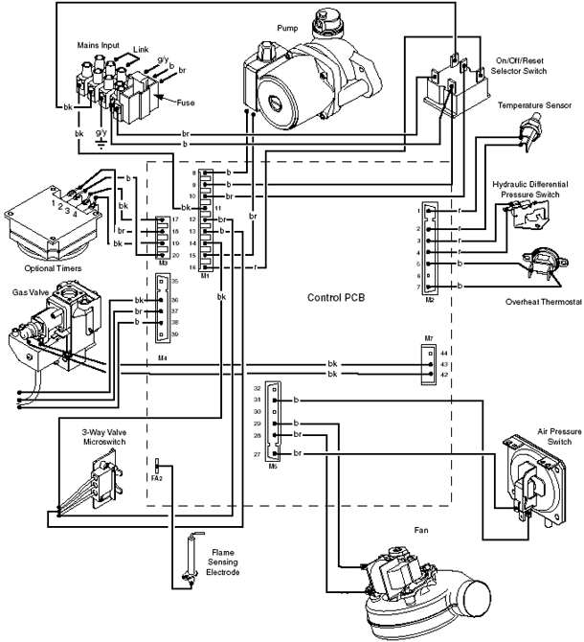
br | - brown | g | - green
bk | - black | g/y | - green / yellow
b | - blue | w | - white
r | - red
Page 37

14.0 Fault Finding
Carry out initial fault finding checks
1. Check that gas, water and electrical supplies are available at the boiler. Electrical supply = 230V ~ 50 Hz.
CH water system pressurised to 0.5 bar when the boiler is cold. The preferred minimum gas pressure is 19.5mbar (natural gas), 27mbar (butane) or 36mbar (propane).
2. Carry out electrical system checks, i.e. Ground Continuity, Resistance to Ground, Short Circuit and Polarity with a suitable meter.
NOTE: These checks must be repeated after any servicing or fault finding.
3. Ensure all external controls are calling for heat and check all external and internal fuses. Before any servicing or replacement of parts ensure the gas and electrical supplies are isolated.
Refer to Section 13.0 "Illustrated Wiring Diagram" for position of numbered terminals
Central Heating - Follow operational sequence
NOTE: When instructed to turn the selector to the reset position turn the selector switch fully anticlockwise against the spring pressure to position R and hold for at least 3 seconds to reset the boiler.
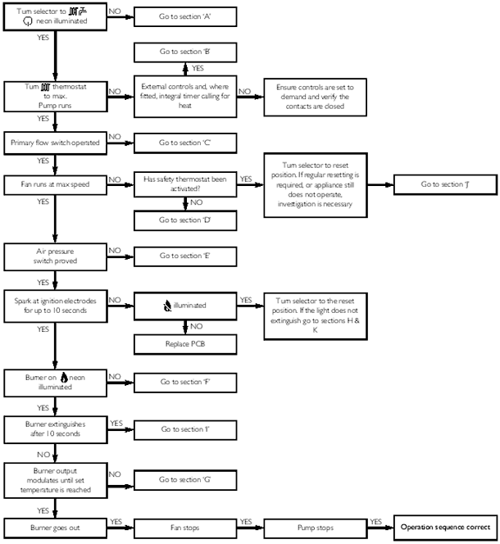
Page 38

Domestic Hot Water - Follow operational sequence
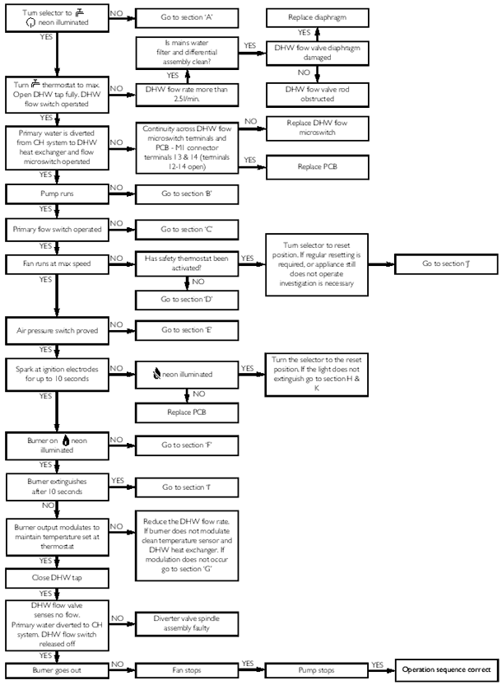
Page 39

Fault Finding Solutions Sections A to E
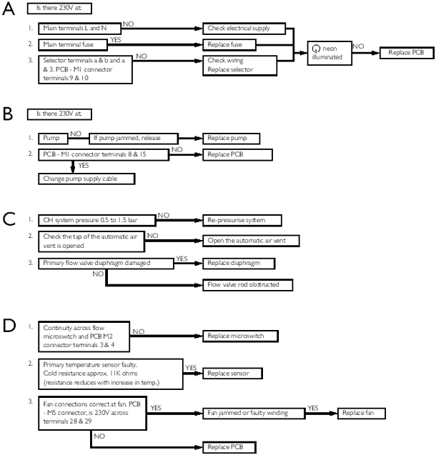
Page 40

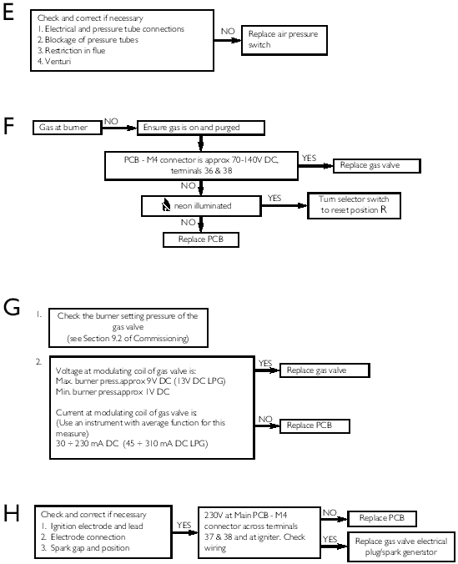
Page 41

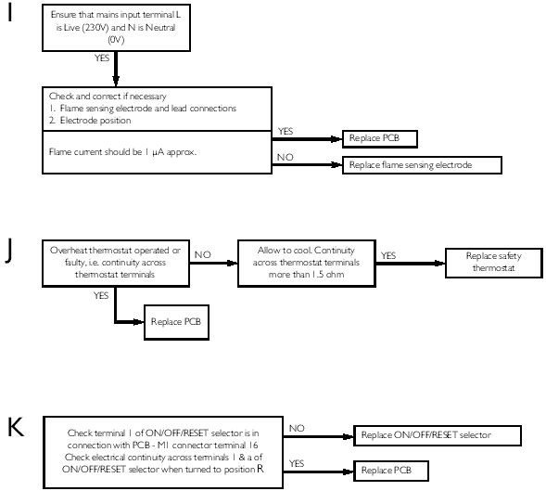
Page 42

15.0 Short Parts List
Short Parts List
Key No. | G.C. No. | Description | Manufacturers Part No.
22 | E66 383 | Fan | 248001
23 | 393-497 | Pressure Switch | 247380
32 | E66 393 | Heat Exchanger | 248016
41 | E66 398 | Burner | 248029
44 | E66 402 | Injector - 1.28 NG | 248210
44 |  | Injector - 0.77 LPG | 248211
59 | E66 408 | Electrode Lead | 248037
63 | E66 432 | Spark or Sensing Electrode | 247384
72 | E66 413 | Pump Complete | 248244
101 | E66 402 | Hydraulic Outlet Assembly | 248061
102 | E66 434 | Valve - 3-Way Assembly | 248062
103 | 343 619 | Pressure Differential Assy | 248063
131 | E05 234 | Temperature Sensor | 248068
135 |  | Safety Limit Thermostat | 248079
140 |  | Gas Valve | 5107339
154 |  | PCB | 5112657
169 | E66 453 | Pressure Gauge | 248090
A |  | Gas Valve Plug/Spark Generator & Lead | 5112385

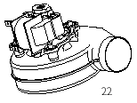

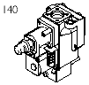

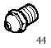

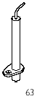

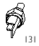

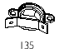

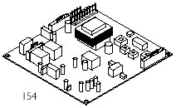

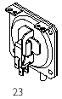

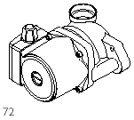

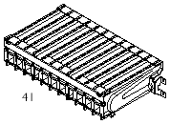

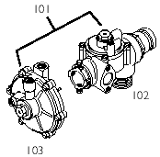

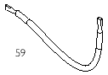

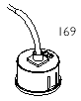

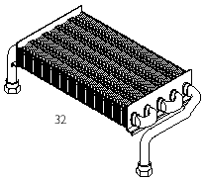

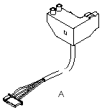
Page 43

BAXI POTTERTON
A Trading Division of Baxi Heating UK Ltd
Brownedge Road Bamber Bridge Preston Lancashire PR5 6UP
After Sales Service 08706 096 096 Technical Enquiries 08706 049 049
Website www.baxi.co.uk
A BAXI GROUP company
923.261.1
Comp No 5113929 - Iss 1 - 10/04
Page 44

